WEBSITE IDEAS
PAGES
- Home
- “Dedicated to improving public understanding of hazardous Great Lakes currents and ending preventable fatal and non-fatal drownings”
- Powerful image
- Upcoming events

- About Us

- Rip Currents 101
- Water Safety Education
- For Schools & Educators
- For Families & Beachgoers

- Resources
- Printable materials - FREE brochure
- Videos
- Links to trusted partners (Chris Houser, NOAA, etc.)

- News & Updates

Get Involved – (should this be its own page? Or within another?)
- Volunteers
- Community partners
- Sharing the message
- Donations

- Contact

- FAQ

ABOUT US

Why understanding matters

Rip currents are one of the leading causes of drowning on the Great Lakes, yet they are widely misunderstood or overlooked. Unlike dramatic ocean waves, Great Lakes rip currents can form quickly, look deceptively calm, and occur on days when the water appears inviting.

Understanding when, where, and why rip currents occur empowers people to make safer decisions before entering the water. It also helps communities, emergency responders, and decision-makers move from reactive rescue to proactive prevention. When we understand rip current occurrence, we can improve warning systems, public education, beach management, and ultimately save lives.

The story behind this project

The Rip Current Information Project was born out of personal loss, lived experience, and a growing frustration with preventable tragedies. After witnessing firsthand how little accurate, accessible information exists about Great Lakes rip currents—and how often warnings come too late—this project was created to close that gap.

What began as one person asking hard questions has grown into a collaborative effort focused on translating science into practical, life-saving information. This project exists because people should not have to learn about rip currents through tragedy. We believe that clear communication, shared knowledge, and early awareness can change outcomes.

Who we serve

We serve everyone who interacts with the Great Lakes - residents, visitors, families, anglers, paddlers, swimmers, and beachgoers of all ages. We also support first responders, municipalities, educators, and community organizations by providing reliable information that can inform safety messaging, policy, and on-the-ground decision-making.

At our core, we serve people who may never realize they were at risk and that’s the point. If someone goes home safely because they understood the conditions that day, our work has done its job.

Rip Currents 101

What Is a Rip Current?

A rip current is a powerful, narrow stream of water that flows away from shore.
- It forms when waves push water toward the beach faster than it can return naturally, forcing the water to funnel back out through:
  - Deeper or weaker point in the nearshore zones
  - Between sandbars
  - Near to structures like breakwalls, rock formation, jetties, groins, etc.
Rip currents are not undertows
- rips do not pull people under the water (neither does an undertow)
- rips are strongest at the surface of the water
- rips can quickly carry even strong swimmers away from shore leading to exhaustion, panic, and drowning if the person does not know how to respond.

How to Spot a rip?

Rip currents are often difficult to see, especially on the Great Lakes, but there are common warning signs to watch for:
- A noticeable break or gap in the incoming waves
- Waves break on sandbars; rips flow in the deep channels between
- A channel of darker or murkier water extending away from shore
- Debris, or sediment moving steadily offshore
- A section of water that looks different - choppy, rippled, or unusually calm compared to surrounding areas

Conditions can change quickly, and rip currents may be present even when the beach looks calm.
When in doubt, stay out of the water or swim near lifeguards when available.

What To Do If You Are Caught in a Rip Current

If you find yourself being pulled away from shore:
- Stay calm and try not to fight the current
- FLOAT to conserve energy
- It is possible to swim parallel to the shoreline to escape narrow/slow channel rip currents
- Once free, angle back toward shore with the waves
- Sandbars can sometimes be a place to catch your breath

If you see someone else in trouble:
- Do not enter the water
- Call for help
- Alert emergency services
- Throw something that floats, if possible.

Knowing what to do→ before you enter the water→ can make the difference between a close call and a tragedy.

Rip Currents on the Great Lakes

There are important clarifications to make when talking about Great Lakes rip currents:
- They are less expected than on an ocean.
  - Many people do not associate large freshwater lakes with rip currents, leading to a false sense of security.
- They form near structures.
  - Piers, breakwalls, and jetties can intensify rip currents on the Great Lakes, creating fast-moving currents close to the structure and shore.
- Wave patterns are different.
  - Great Lakes waves crash more quickly in succession than ocean waves.
  - Great Lakes waves are driven by wind and can change rapidly, causing rip currents to form suddenly and in some cases, disappear just as quickly.
Understanding these differences is critical for anyone recreating on or near the Great Lakes.

Types of rip currents
- Bathymetrically-controlled
  - Channelized rip currents
  - Focused rip currents
- Structurally-controlled
  - Shadow rip currents
  - Deflection rip currents
- Hydrodynamically-controlled
  - Flash rip currents
  - Shear-instability rip currents

Bathymetrically-controlled rip currents
Rip currents controlled by the shape and contours on the lake bottom, this can be nearshore or offshore features
Channelized rip currents
- The most documented and well understood rip current type.
- Occupy deeper channels that interrupt shallow, mostly shore-parallel sandbars.
- Can persist in a relatively fixed location for days, weeks, or months and are relatively easy to identify.
- Typically range in
  - widths from 5 to 100 m
  - depths 1-3 m or more
  - may be spaced anywhere from 50 to 500 m apart
Focused rip currents
- Occur at relatively fixed locations
- Are controlled by alongshore variations in breaking waves created by offshore bathymetric features
ie; submarine canyons, submerged ridges, or offshore sand bars.
- Can occur along flat, featureless beaches where they typically appear as offshore directed plumes of turbulent water and sediment.
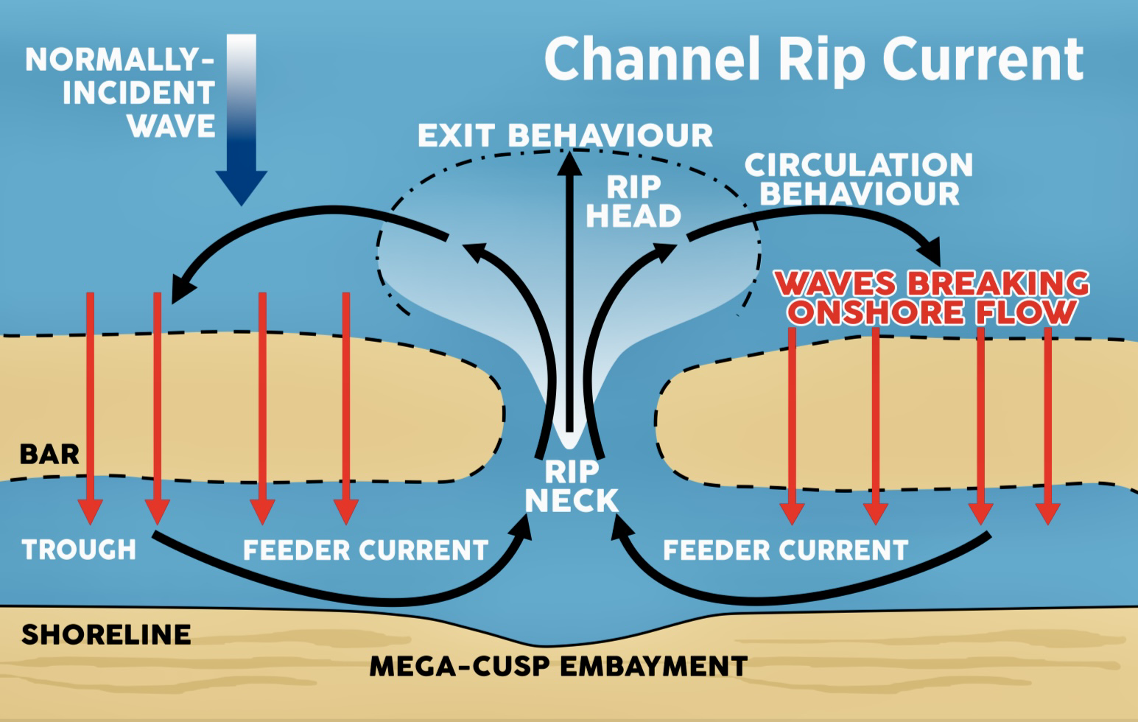

Structurally-controlled rip currents
- Occur adjacent to man-made structures such as breakwalls, jetties, and piers
- Are persistent in location
- Can occur during small breaking wave conditions.
- Sometimes associated with deeper water adjacent to structures, and in these cases appear as areas of darker water with reduced wave breaking activity.
- They can be grouped into two types based on how and where they form
  - Shadow rips
  - Deflection rips.
- These types can exist simultaneously on each side of the structure.
Boundary-Controlled rip currents
- Occur adjacent to natural geologic features, such as headlands and rock outcrops.

Shadow rip currents
- flow on the sheltered side (down-wave) of a rigid structure or boundary.
- On straight beaches, the presence of a rigid obstacle creates alongshore variations in breaking waves
- Wave setup tends to be higher away from the structure due to larger waves, and lower closer to the structure due to smaller waves (as this region is more protected from wave energy).
- This pressure gradient forces water “downhill” in the alongshore direction, back toward the obstacle and then offshore as a rip current alongside the obstacle.

Deflection rip currents
- Occur on the exposed side (up-wave) of a rigid structure or boundary.
- On straight beaches, waves approaching and breaking against the shoreline at an angle can create strong alongshore currents that are physically deflected lakeward when they reach the structure and flow offshore adjacent to it.
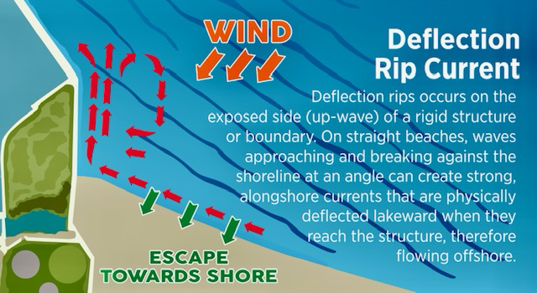

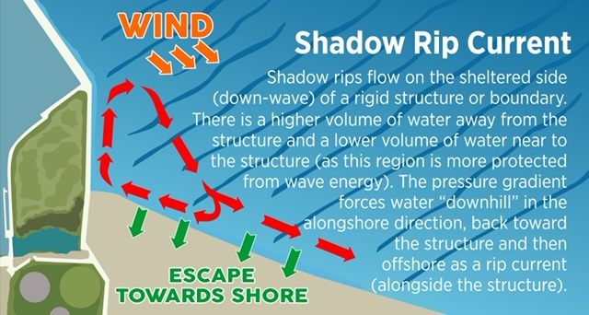

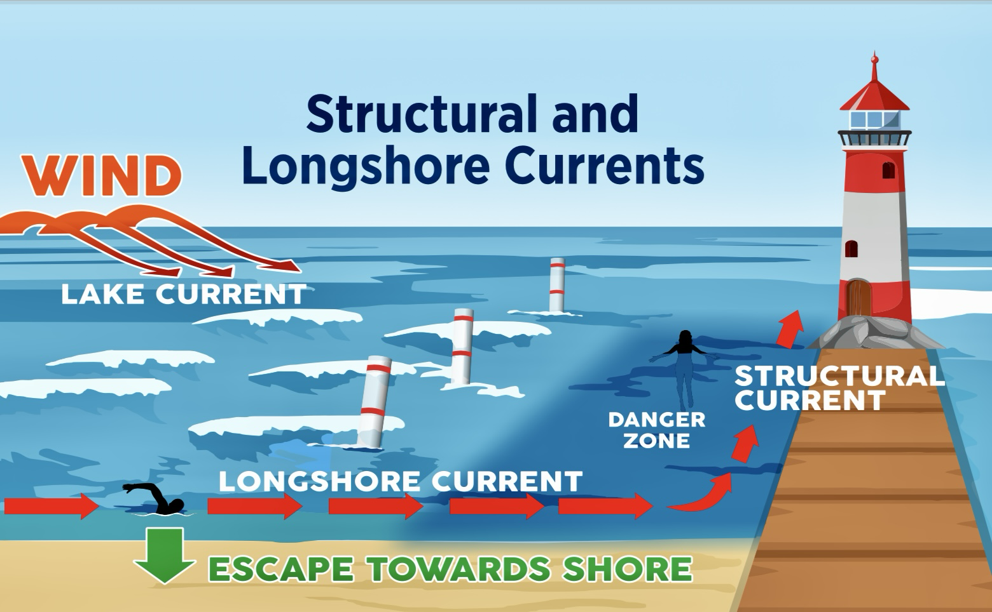

Hydrodynamically-Controlled Rip Currents
- Controlled solely by hydrodynamics (wave and current interactions)
- Occur on featureless straight beaches.
- It is not possible to predict the exact location and timing, but it may be possible to estimate the likelihood of their formation.
- Typically appear as narrow bands of turbulent whitewater and sand extending offshore of the surf zone
- Less is known about their flow speed and duration due to a lack of field measurements
They can be grouped into two types:
  - Flash rip currents (Transient rips)
    - form when waves that break in short sections, or “short-crested waves”, drive small swirling flows or “eddies” that merge
    - lasting for several minutes.
  - Shear instability rip currents
    - Form when eddies are shed off of longshore currents as a result of waves breaking at an angle to the coast.

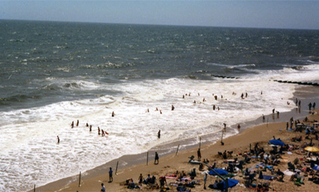

Water safety education

Water Safety Education
- Effective water safety education saves lives when:
  - It is age-appropriate
  - Evidence-informed
  - Delivered by people who understand the real mechanisms.
- Our education programs are intended to meet learners where they are, whether in the classroom, at the beach, or within the community.

Age-Appropriate Learning
We are creating education that aligns with developmental stages and existing safety frameworks, example: Grade 3 curriculum concepts and programs such as Swim to Survive.
For younger learners, the focus is on:
- Recognizing unsafe water conditions
- Knowing when not to enter the water
- Understanding basic self-rescue principles
For older students and adults, education expands to:
- Identifying rip current risk factors
- Understanding how weather, wind, and structures influence water conditions
- Making informed decisions before entering the water
Our goal is not to create fear, but to build confidence through knowledge and understanding.

Classroom & Beach-Based Learning
Water safety education is most effective when it connects knowledge to place. We offer learning experiences that take place both indoors and, on the shoreline, tailored for:
- Schools and educators
- Municipal staff and decision-makers
- Emergency responders and rescue personnel
- Community groups and the public
Beach-based learning
- allows participants to observe real conditions, identify hazards, and practice decision-making in a safe, supervised environment.
Classroom learning
- builds the foundation that makes those beach-based observations meaningful.

Evidence-Informed Messaging You Can Trust
All our educational content is grounded in current research and real-world coastal science.
We work closely with leading experts to ensure that the information shared with the public is accurate, practical, and relevant to the Great Lakes.
- This includes collaboration with Dr. Chris Houser, Dean of Science at the University of Waterloo and a leading authority on rip current dynamics.
By sharing evidence-informed messaging directly from those who study these systems and presented by Great Lakes lifeguards that have responded to dangerous current emergencies, we help bridge the gap between science and public safety.

For Schools & Educators

Water safety education works best when it is accessible, age-appropriate, and connected to real places students know. The Rip Current Information Project offers free learning opportunities designed to support educators and enhance existing curriculum, without adding extra burden.

What We Offer
We provide free water safety education resources for schools and educators, including:
- In-person classroom presentations
- On-site beach learning experiences (where appropriate and weather-dependent)
- Age-appropriate lessons tailored to elementary and secondary students
- Materials that complement programs such as Swim to Survive
All sessions are designed to be engaging, interactive, and grounded in real-world Great Lakes conditions.

How a Visit or Presentation Works
- You get in touch to share your school’s needs, grade level, and preferred format
- We tailor the session to your students and location
- The presentation is delivered in your classroom or at a nearby beach
- Students leave with a clear understanding of water safety and rip current awareness
Sessions can range from short assemblies to longer, hands-on learning experiences.

Curriculum Connections
Our programming aligns with key Ontario curriculum goals, including:
- Personal safety and injury prevention
- Environmental awareness and systems
- Decision-making and risk assessment
- Physical literacy and water safety fundamentals
Educators can confidently integrate these sessions into existing lesson plans while reinforcing critical life skills.

How to Book the Rip Current Information Project
Booking is simple:
- Contact us through the website booking form or email
- Let us know your school, grade level, and preferred date(s)
- We’ll follow up to confirm details and logistics
There is no cost for schools. Our goal is to remove barriers and ensure that water safety education is available to all students.
For Families & Beachgoers

A day at the beach should be fun, relaxing, and safe. Understanding basic water safety helps families enjoy the Great Lakes while reducing risk, especially when the Great Lakes change quickly.

Simple Safety Tips
- Check the weather, wind, and water conditions before you go
- Be cautious on windy days or after storms, even if the sun is out
- Stay well away from piers, breakwalls, and jetties
- Swim near lifeguards, when they are present (Guarded beaches are statistically safer)
- If conditions do not feel right, choose not to enter the water
You do not need to be an expert. A few informed choices can make a big difference.

What Parents Should Know
- Rip currents occur on the Great Lakes and can be difficult to spot
- Dangerous currents may exist even when the water looks calm and after a storm passes
- Children can be pulled into deeper water very quickly
- Many water emergencies happen close to shore, near structures and in the deep areas around sandbars
The most important safety decisions often happen before anyone enters the water.

Talking to Kids About Water Safety
Children don’t need the scary details, they need clear, simple rules.

Helpful ways to talk about water safety include:
- “We check the water conditions before we swim.”
- “If the water is rough or the waves are big, we stay out.”
- “If you feel tired or if you feel that you are being pulled away from shore, FLOAT and wave for help.”
Encourage kids to:
- Always swim with an adult supervising – Best option is to “Stay within arm’s reach”
- Stay where they can touch the bottom - The more of your body that is under the water the more the water can move you around.
- Tell an adult if something feels wrong – “That’s GOOD communication!”
Water safety is not about fear—it’s about knowing when to say yes and when to say no.
- The goal is getting everyone home safely. It’s okay to leave the beach without swimming.

Resources

The Rip Current Information Project provides free, reliable resources to help individuals, families, educators, and communities better understand water safety on the Great Lakes.
All materials are evidence-informed and intended for public use.

Printable Materials
We offer free educational printables that can be used at home, in classrooms, or shared within the community.
- Rip Current awareness brochures
- Beach safety checklists
- Age-appropriate learning materials
All printable resources are designed to be clear, accessible, and easy to share.

Educational Videos
Our educational videos explain rip currents and water safety concepts in a simple, visual way. These videos are suitable for:
- Classroom use
- Community presentations
- Family viewing before a beach visit
Videos focus on real Great Lakes conditions and practical safety messaging.

Trusted Partners & Evidence-Based Sources
We collaborate with and reference organizations and experts who are leaders in water safety and coastal science, including:
- Dr. Chris Houser, Dean of Science, University of Waterloo
- The Lifesaving Society
- Canadian Coast Guard
- Regional emergency management and public safety partners
These partnerships help ensure our messaging reflects current research and best practices.

Media Coverage & Public Awareness
The Rip Current Information Project has been featured in media coverage highlighting the importance of rip current awareness on the Great Lakes.
This includes:
- News articles and interviews
- Community features and public education stories
Coverage that helps extend water safety messaging to a wider audience

Past Media Coverage
The Rip Current Information Project has been featured in media coverage focused on Great Lakes safety, drowning prevention, and public education initiatives.
This includes:
- News articles
- Radio and television interviews – CBC, CTV, MyFM, Established Media, etc.
- Community safety features
(Some links available below.)
- https://lfpress.com/news/local-news/ex-lifeguard-launches-non-profit-to-combat-rip-current-dangers
- https://www.elgincounty.ca/2025/06/from-the-council-chambers-june-24-2025/
- https://www.facebook.com/establishmedia/videos/a-chat-with-nathan-macintyre-ceo-of-the-rip-current-information-project/1253768263149491/
- https://www.pentictonherald.ca/spare_news/article_112193c5-79a7-5bb6-b20a-ac08e49e8236.html#:~:text=Former%20Port%20Stanley%20lifeguard%20Nathan,concentrated%20water%20flow%2C%20MacIntyre%20said

Logos, Images & Assets

Downloadable media assets are available for use in coverage of the Rip Current Information Project, including:
- RiP logo
- Approved images
- Educational graphics
Please credit the Rip Current Information Project when using these materials.

Media Contact

For interview requests, expert commentary, or background information:

Nathan MacIntyre
Founder, CEO, Rip Current Information Project
RipSafety1@gmail.com
ripcurrents.org

Also check out our Media Kit on the Contact page!

BEACH CHECKLIST

These are examples of good considerations. YOU can add to this list to enhance your safety and the safety of your family.

Before You Go to the Beach:

A Quick Safety Checklist
- Before heading to the beach, take a moment to check conditions. A few minutes of preparation can prevent a dangerous or deadly situation.
Check the Conditions
- Review the weather and wind forecast for the day
- Pay attention to wind direction and strength, not just temperature
- Be cautious on windy days or after storms, even if the sky looks clear
Know the Water
- Understand that rip currents can form quickly and without warning
- Remember that calm-looking water can still be dangerous example: after a storm
- Be extra cautious near piers, breakwalls, and jetties
Look for Warnings
- Observe flags, signs, or posted advisories at the beach
- Respect beach closures or swimming restrictions
- Swim near lifeguards when available
Plan Before You Enter
- Decide where you will swim before entering the water
- Talk with family or friends about what to do if someone gets pulled away
- Make sure children know to stay close and where to find help
Be Ready to Help - Safely
- Never enter the water to rescue someone caught in a current
- Call 911 or local emergency services immediately
- Throw or extend something that floats - don’t go
When in Doubt
- If conditions feel uncomfortable or confusing, stay out of the water
- Swimmers in the water does not mean the water is safe.
- There is no shame in choosing safety over swimming
One Simple Rule to Remember
- Don’t let your first safety check happen in the Lake.
This means:
  - If you haven’t first checked the weather, wind, and water conditions, it’s best to stay out. Local knowledge can be helpful.
  - Rip currents and other dangerous conditions are not always obvious from the shoreline.
  - The water may look calm, inviting, or shallow near the edge, but strong currents can exist just a few steps out.
  - Many people are caught in rip currents because they entered the water casually, to cool off, to wade, or to test the temperature, without realizing the risk.
- Checking the conditions before you arrive helps you decide whether entering the water is safe at all.
  - If you haven’t done that check, the safest choice is to stay out of the water until you know!

Don’t let your first safety check happen in the water.

Get Involved

Preventing drowning and improving Great Lake water safety is a shared responsibility. The Rip Current Information Project exists because people care - there are many ways to be part of this work, no matter your background or availability.

Volunteers
Volunteers play an important role in helping rip current safety information reach the public. Whether you have a few hours or ongoing availability, your time can make a real difference.
Volunteer opportunities may include:
- Supporting community education or outreach events
- Helping distribute educational materials during peak beach season
- Assisting with public awareness initiatives and campaigns
- Supporting behind-the-scenes planning or coordination
No prior water safety experience is required. Volunteers receive guidance and clear messaging so they feel confident sharing accurate, evidence-informed information.

Community Partners
Strong partnerships help ensure water safety messaging is consistent, visible, and effective. We work alongside organizations that serve communities along the Great Lakes shores and beyond.
Potential partners include:
- Municipalities and public works departments
- Schools and school boards
- Emergency responders and safety agencies
- Community groups, nonprofits, and local businesses
Partnerships may involve
- co-hosted events
- shared resources
- joint education initiatives
- advisory support
Collaboration allows us to reach more people and tailor messaging to local conditions.

Sharing the Message
You don’t need to volunteer formally to make an impact. Simply sharing accurate rip current information helps normalize safe decision-making around the water.
Ways to share the message include:
- Posting RiP resources on social media
- Sharing safety information before group beach outings
- Encouraging friends and family to check conditions before swimming
- Using RiP materials in classrooms, camps, or community settings
Small conversations can prevent big emergencies.

Donations
The Rip Current Information Project is committed to keeping water safety education free and accessible. Donations help sustain and expand this work.
Contributions support:
- Free public education materials and resources
- School and community outreach programs
- Ongoing collaboration with scientists and safety professionals
- The development of new tools and educational content
Every donation helps remove barriers to education and strengthens prevention-focused water safety efforts.

Thank You!!
Whether you volunteer, partner, share information, or donate, your involvement helps protect lives.
This work is only possible because people like you choose to care.

News & Updates

The Rip Current Information Project shares updates to keep our community informed, engaged, and prepared. This space highlights ongoing education efforts, community partnerships, and timely safety information throughout the year.

School Visits & Education Programs
We regularly visit schools to deliver age-appropriate water safety education focused on rip current awareness and informed decision-making.
We are working on:
- Classroom presentations
- Student engagement activities
- Curriculum-aligned learning experiences
- Rip current dioramas
- Children’s books
- And MORE!
These visits help build early understanding and long-term safety habits.

Community Events & Outreach
RiP participates in community events, workshops, and public safety initiatives across the province.
This includes:
- Beach safety days
- Public awareness campaigns
- Collaborative events with municipalities and partners
Community engagement strengthens shared understanding and responsibility for water safety.

Understanding Rip Current Incidents
When rip current incidents occur, they often raise important questions. Where appropriate, RiP provides educational explanations to help the public understand:
- The conditions that contributed to increased risk
- How rip currents form in those environments
- What preventative actions may reduce future incidents
These explanations are shared respectfully and without speculation or blame, with the goal of improving understanding – not sensationalizing tragedy.

Seasonal Safety Reminders
Water conditions change with the seasons. RiP shares timely reminders to help people stay safe year-round.
Seasonal updates may include:
- Spring and early-season water hazards
- Summer rip current awareness during peak beach use
- Fall and shoulder-season safety considerations
Clear, timely information helps people make safer choices before heading to the water.

Contact

We’d love to hear from you! Whether you are an educator, journalist, community partner, or simply looking for more information, please reach out.

General Inquiries
For questions about the Rip Current Information Project, resources, or collaborations:
- Email: RipSafety1@gmail.com

Speaking Requests
Nathan MacIntyre is available for speaking engagements related to:
- Rip current rescue, science, awareness and water safety
- Great Lakes specific risk and prevention
- Great Lakes lifeguarding expertise
- Community education and public safety events
- “Understanding rip currents” – PowerPoint presentation ~60minutes
Speaking requests may include conferences, community events, municipal meetings, Beach sessions, public awareness initiatives and more.

Presentations are tailored to the audience and grounded in real-world conditions.
To request a speaker, please include:
- Event name and location
- Preferred date(s) and format
- Audience type and size

School Inquiries
Schools and educators interested in FREE water safety education are encouraged to get in touch.
Please include:
- School name and location
- Grade level(s)
- Preferred format (classroom or beach-based)
- Preferred timing
We’ll follow up to discuss options and logistics.
A Quick Note
- We do our best to respond to all inquiries as quickly as possible.
Thank you for your interest in improving water safety and helping prevent drowning on the Great Lakes!

Municipalities & Local Governments
Presentations for municipal audiences focus on:
- Understanding rip current occurrence and local risk factors through Facility Audits
- Improving public safety messaging and signage through Standardized Language
- Supporting proactive, prevention-based beach management
- Aligning education efforts across departments and partners
These sessions are especially relevant for parks and recreation, emergency management, public works, and council or committee briefings.

Rescue Agencies & Emergency Responders
Sessions for rescue agencies emphasize:
- Rip current science and types of rips
- How conditions and structures influence rescue risk
- Prevention messaging that reduces the need for rescue
- Supporting responder safety through public education
This content is designed to complement training by strengthening existing rescue protocol as well as the prevention side of emergency response.

Additional Audiences & Settings
Speaking engagements are also available for:
- Schools, school boards, and educator conferences
- Community organizations and nonprofits
- Waterfront associations and beach communities
- Public safety conferences and workshops
- Environmental or Great Lakes focused events
Each session is adapted to the audience’s level of familiarity and specific context.

Media Kit

The Rip Current Information Project (RiP) is a Great Lakes focused public safety initiative dedicated to improving understanding of rip current occurrence, risk, and prevention through clear, evidence-informed communication.

This kit provides journalists and media professionals with accurate background information, key messages, and contact details to support responsible reporting.

About the Rip Current Information Project

The Rip Current Information Project is a Canadian, Ontario-based public safety initiative focused on reducing drowning risk on the Great Lakes by improving awareness of rip current occurrence and conditions.
RiP exists to bridge the gap between coastal science and public understanding so people can make safer decisions before they enter the water.

Why This Work Matters

- Rip currents are a leading cause of drowning on the Great Lakes
- Many people do not expect rip currents in freshwater
- Dangerous conditions can exist even when the water looks calm
- Prevention begins with understanding when and why risk increases
- RiP focuses on proactive education, not reactive tragedy response.

Key Messages for Media

Journalists covering rip currents or Great Lakes water safety are encouraged to emphasize the following:
- Rip currents occur on the Great Lakes and can form quickly
- Calm-looking water is not always safe
- Wind, waves, and shoreline structures strongly influence risk
- Checking conditions before entering the water saves lives
- Most drownings are preventable with better awareness

Founder & Spokesperson

Nathan MacIntyre
Founder, CEO of Rip Current Information Project
Nathan MacIntyre is a water safety advocate whose work is rooted in lived experience, community engagement, and collaboration with coastal scientists and emergency responders. He founded the Rip Current Information Project to address gaps in public understanding around Great Lakes rip currents and to promote prevention-focused safety messaging.
Nathan is available for media interviews, expert commentary, and public education discussions related to rip currents, beach safety, and drowning prevention.

Evidence-Informed Approach

RiP’s messaging is grounded in current research and expert insight. The project works closely with leading coastal scientists, including Dr. Chris Houser, Dean of Science at the University of Waterloo and an internationally recognized expert in rip current dynamics.

By sharing evidence-informed information directly from those who study these systems, RiP helps ensure accuracy, clarity, and consistency in public-facing safety communication.

Media-Ready Quotes

“Most people don’t realize rip currents happen on the Great Lakes. That misunderstanding is a risk factor.”

“The most important safety decision happens before you enter the water. Checking weather conditions saves lives.”

“You don’t need to be an expert to stay safe. You just need the right information at the right time.”

“Rip currents are strongest at the surface. Rips pull you away from shore. Rips do not pull you under the water.”

(Additional quotes available upon request.)

FAQ

“Are you a charity?”

“Are your programs really free?”

“How long are the presentations?”

“Are the presentations suitable for young children?”

